Product Life Cycle of McDonalds
Name of Student
Name of Professor
Course
Date

The product life cycle is the course that product sales and profits take over in a lifetime (Bookshelf Online, 018). The brand that I will be discussing is the McDonalds brand from McDonald's Corporation.
The McDonald's brand was founded in 1940 as a fast food restaurant operated by Richard and Maurice McDonald, in San Bernardino, California in the United States. The company was started as a hamburger stand and later turned the company into a franchise. The logo for McDonald The Golden Arches Logo was introduced in 1953 at a place in Phoenix, Arizona (Oyedele, 2018). McDonald's let customers choose from the McChicken, Mcdouble and a small fry. Its rival products were cheaper, so they had to come up with some kind of price strategy.
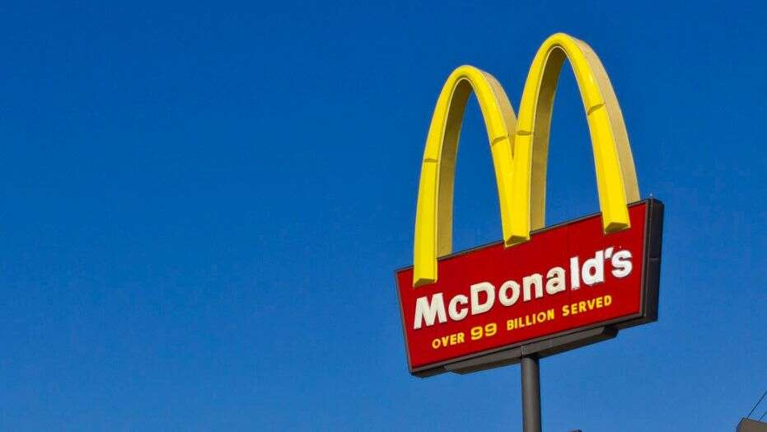

The Golden Arches Logo for McDonalds
In the growth period, the product engaged in vigorous promotion to introduce it into the market. In 1955, he founded McDonald's System, Inc., a predecessor of the McDonald's Corporation, and six years later bought the exclusive rights to the McDonald's name. By 1958, McDonald's had sold its 100 millionth hamburger. The Mcdonald hamburger and fast-food chain of restaurants grew its popularity in the state to a level of being identified as the best hamburger and fast food store in several states in the United States. Although the price was relatively lower for average Americans since fast foods were entering the market at a quicker pace (Dulaney, 2018). As a result, the profits were rising, and the growing number of customers was very evident, also, return customers were experienced, and demand started increasing proportionally.
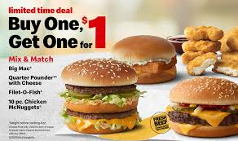

A commercial for McDonald's

During the maturity stage, McDonald's has matured over the years by adding more items to their menu. They have shown competitors that they are better by introducing new products that put a smile on their customers' faces. McDonald's, however, defending its market share and try to maximize its profit. Sales were also affected as the company went through some hard times by entering the global market and facing international regulations (Oyedele, 2018). However, McDonald's had a surge in popularity when they promoted their product through diversifying brands and models, building more intensified distribution of their chains in the global market to increase their sales. The price of the product was maintained despite the award that they were given, thus competing effectively with their competitor. Peak sales were experienced at this stage, while customer loyalty was developed across the globe (Services & amenities, 2018). Also, due to economies of scale, the company was able to improve the quality of the product and also added other products in their chains at favorable prices.
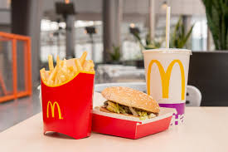

Various products from McDonald
At the declining stage, McDonald's reported sharper-than-expected sales declines in all its divisions in November. The U.S. slide was the largest, with sales falling 4.6% from the same month a year ago, far more than the 1.9% drop analysts had projected and more than September's 4.1% sales slide in what was then the company's biggest monthly drop since early 2003 (Mcdonald's, 2018). McDonald's blamed the decline on "strong competitive activity" and said it is "diligently working to enhance its marketing, simplify the menu, and implement a more locally driven organizational structure to drop since early 2003 and rease relevance with consumers (Oyedele, 2018). The company also faced stiff competition from products such as Burger King. However, the company maintained its most of the customers during this stage, and its profit generation was restored to a constant level. There was a rapid and vigorous advertisement and promotion as the product faced stiff competition in the market.
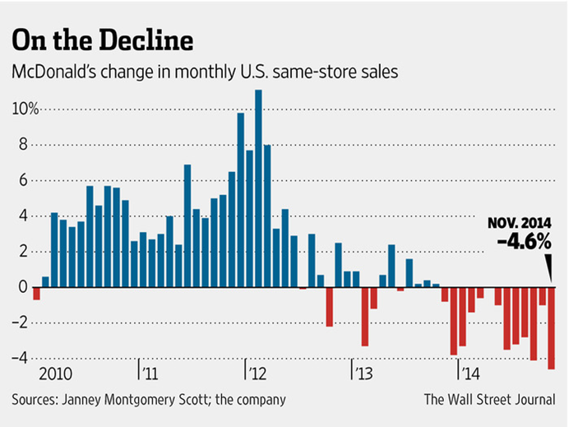

McDonald’s sales decline

References
Services & amenities: wi-fi, playplaces & more | mcdonald's. (2018). Mcdonalds.Com. Retrieved 23 january 2018, from https://www.Mcdonalds.Com/us/en-us/services.Html
Dulaney, j. (2018). Mcdonald’s decline in U.S. Sales accelerates. Wsj. Retrieved 23 january 2018, from https://www.Wsj.Com/articles/mcdonalds-november-sales-fall-more-than- expected-1418044377
Bookshelf Online. (2018). Phoenix.vitalsource.com. Retrieved 23 January 2018, from https://phoenix.vitalsource.com/#/books/1260177580/cfi/6/52!/4/62@0:75.9
Oyedele, A. (2018). McDonald's beats on earnings after slashing prices on soda and coffee. Business Insider. Retrieved 23 January 2018, from http://www.businessinsider.com/mcdonalds-earnings-sales-q2-2017-2017-7
Mcdonald’s ‘think global, act local’ pricing approach. (2018). T1 2016 MPK732 Marketing Management (Cluster B). Rerieved 23 January 2018, from http://mpk732t12016clusterb.wordpress...think-global-act-local-pricing-appraoch/

